Teacher Guide for the Free AtomTouch App

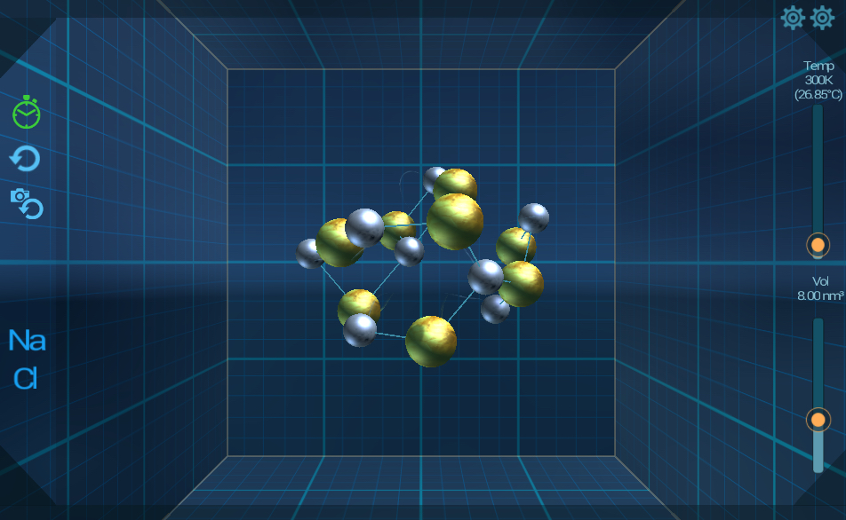
AtomTouch is a free, 3D, touch screen app designed by scientists to give students a hands-on understanding of how sodium and chloride atoms behave in the real world under various conditions.

AtomTouch can be used to address the Next Generation Science Standards in multiple curricular units, including:
- States and Properties of Matter
- Predicting and modeling how atoms behave as materials change state
- Figure out the most stable structure for a molecule
- Atomic and molecular Theory
- Physical and Chemical Interactions
- Properties of atoms, molecules, and matter
- Size and Scale

Time needed: 20-60 minutes depending upon how much of the app you choose to use

Equipment needed: AtomTouch works best on a touch screen device (tablet, iPad, cell phone) although it can be used online with a mouse. AtomTouch can be downloaded to the devices at this link: https://mobile.wisc.edu/mli-projects/project-atomtouch/ or directly from the Apple Store or the Google Play store.

Additional Notes:
1) AtomTouch is based upon a molecular dynamics simulation, which means that atoms behave according to scientific data and physical laws. The Atomtouch_teacherslides.ppt file contains slides about molecular dynamics simulations.
2) AtomTouch includes a walkthrough that covers the learning objectives listed. Questions and answers embedded in the walkthrough help ensure that users understand what is happening in each activity.
3) There is also a Sandbox option that allows uses to explore the world of atoms and atomic behavior by building limitless structures under various physical conditions.
4) The launch video includes a scale bar to give students real-world context about the size of atoms relative to grains of salt.

